Name: Anirban Das Batch: BCSE-II Session: 2020-21
Roll No.: 001910501077
Second Semester Experiments in Microprocessor Lab

Problem Sheet #3

1. A set of N data bytes is stored in m/m locations starting from 2501H. The value of N is stored in 2500 H . Write a program to store these data bytes from m/m location 2600 H if D 0 or D 7 is 1; otherwise reject the data byte.

Line# | Address in Hex | Label | Instruction | Opcode (in hex) | Remarks
1 | 0800 |  | LDA 2500H | 3A | A = M[2500H]
2 | 0801 |  | LDA 2500H | 00 | A = M[2500H]
3 | 0802 |  | LDA 2500H | 25 | A = M[2500H]
4 | 0803 |  | MOV C, A | 4F | C = A
5 | 0804 |  | LXI H, 2501H | 21 | H = 2501H
5 | 0805 |  | LXI H, 2501H | 01 | H = 2501H
5 | 0806 |  | LXI H, 2501H | 25 | H = 2501H
6 | 0807 |  | LXI D, 2600H | 11 | D = 2600H
6 | 0808 |  | LXI D, 2600H | 00 | D = 2600H
6 | 0809 |  | LXI D, 2600H | 26 | D = 2600H
7 | 080A | START | MOV A,M | 7E | A = M
8 | 080B |  | ANI 01H | E6 | A = A AND 01H
8 | 080C |  | ANI 01H | 01 | A = A AND 01H
9 | 080D |  | JNZ STORE | C2 | Jump to STORE if zero does not occur
9 | 080E |  | JNZ STORE | 1C | Jump to STORE if zero does not occur
9 | 080F |  | JNZ STORE | 08 | Jump to STORE if zero does not occur
10 | 0810 |  | MOV A,M | 7E | A = M
11 | 0811 |  | ANI 80H | E6 | A =A AND 80H
11 | 0812 |  | ANI 80H | 80 | A =A AND 80H
12 | 0813 |  | JNZ STORE | C2 | Jump to STORE if zero does not occur
12 | 0814 |  | JNZ STORE | 1C | Jump to STORE if zero does not occur
12 | 0815 |  | JNZ STORE | 08 | Jump to STORE if zero does not occur
13 | 0816 |  | INX H | 23 | H -> H + 1
14 | 0817 |  | DCR C | 0D | C = C - 1
15 | 0818 |  | JNZ START | C2 | Jump to START if zero does not occur
15 | 0819 |  | JNZ START | 0A | Jump to START if zero does not occur
15 | 081A |  | JNZ START | 08 | Jump to START if zero does not occur
16 | 081B | STORE | MOV A,M | 7E | A = M
17 | 081C |  | STAX D | 12 | Store value of D at desired location
18 | 081D |  | INX D | 13 | D -> D + 1
19 | 081E |  | INX H | 23 | H -> H + 1
20 | 081F |  | DCR C | 0D | C = C - 1
21 | 0820 |  | JNZ START | C2 | Jump to START if zero does not occur
21 | 0821 |  | JNZ START | 0A | Jump to START if zero does not occur
21 | 0822 |  | JNZ START | 08 | Jump to START if zero does not occur
22 | 0823 |  | HLT | 76 | Halt

Simulator with loaded machine code:

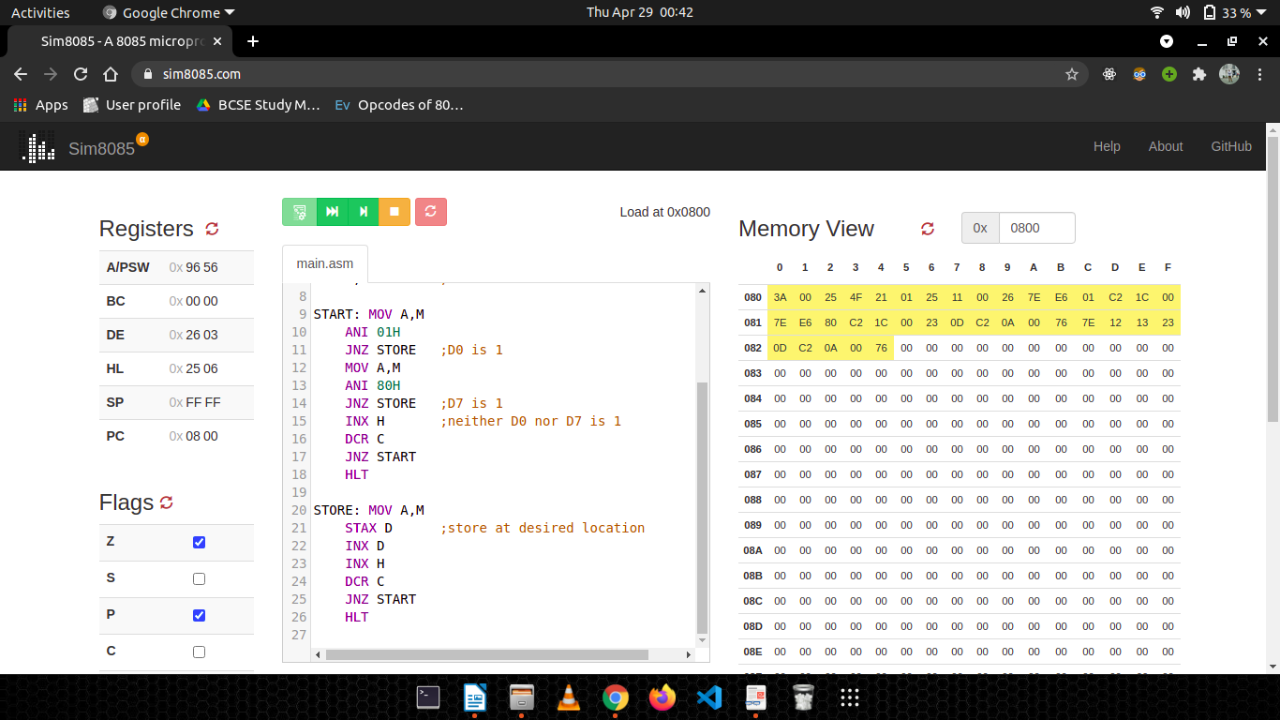

Sample input and output (M[2500]=05H, M[2501]=81H, M[2502]=11H, M[2503]=42H, M[2504]=26H, M[2501]=96H):
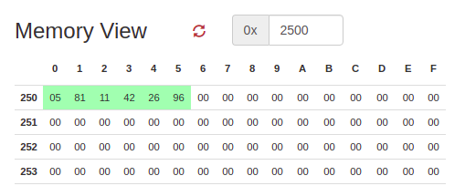

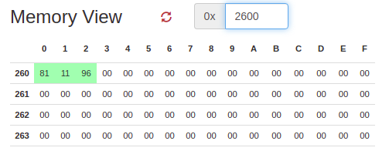

2. There are N data bytes stored from m/m location 2200 H . The value of N is stored in 21FF H . Write an 8085 program to find the sum of integers whose LSB and MSB are 1. Store the result in 2500 H and 2501 H .

Line# | Address in Hex | Label | Instruction | Opcode (in hex) | Remarks
1 | 0800 |  | LDA 21FFH | 3A | A = M[24FFH]
2 | 0801 |  | LDA 21FFH | FF | A = M[24FFH]
3 | 0802 |  | LDA 21FFH | 21 | A = M[24FFH]
4 | 0803 |  | MOV C, A | 4F | C = A
5 | 0804 |  | LXI H, 2200H | 21 | H = 2501H
5 | 0805 |  | LXI H, 2200H | 00 | H = 2501H
5 | 0806 |  | LXI H, 2200H | 22 | H = 2501H
 | 0807 |  | MVI B, 00H | 06 | B = 00H
 | 0808 |  | MVI B, 00H | 00 | B = 00H
 | 0809 |  | MVI E, 00H | 1E | E = 00H
 | 080A |  | MVI E, 00H | 00 | E = 00H
7 | 080B | START | MOV A,M | 7E | A = M
8 | 080C |  | ANI 01H | E6 | A = A AND 01H
8 | 080D |  | ANI 01H | 01 | A = A AND 01H
9 | 080E |  | JNZ PROCEED | C2 | Jump to PROCEED if zero does not occur
9 | 080F |  | JNZ PROCEED | 19 | Jump to PROCEED if zero does not occur
9 | 0810 |  | JNZ PROCEED | 08 | Jump to PROCEED if zero does not occur
10 | 0811 |  | INX H | 23 | H -> H + 1
11 | 0812 |  | DCR C | 0D | C = C - 1
12 | 0813 |  | JNZ START | C2 | Jump to START if zero does not occur
12 | 0814 |  | JNZ START | 0B | Jump to START if zero does not occur
12 | 0815 |  | JNZ START | 08 | Jump to START if zero does not occur
13 | 0816 |  | JMP FINAL | C3 | Jump to FINAL
13 | 0817 |  | JMP FINAL | 33 | Jump to FINAL
13 | 0818 |  | JMP FINAL | 08 | Jump to FINAL
14 | 0819 | PROCEED | MOV A,M | 7E | A = M
15 | 081A |  | ANI 80H | E6 | A = A AND 80H
15 | 081B |  | ANI 80H | 80 | A = A AND 80H
16 | 081C |  | JNZ STORE | C2 | Jump to STORE if zero does not occur
16 | 081D |  | JNZ STORE | 27 | Jump to STORE if zero does not occur
16 | 081E |  | JNZ STORE | 08 | Jump to STORE if zero does not occur
17 | 081F |  | INX H | 23 | H -> H + 1
18 | 0820 |  | DCR C | 0D | C = C - 1
19 | 0821 |  | JNZ START | C2 | Jump to START if zero does not occur
19 | 0822 |  | JNZ START | 0B | Jump to START if zero does not occur
19 | 0823 |  | JNZ START | 08 | Jump to START if zero does not occur
20 | 0824 |  | JMP FINAL | C3 | Jump to FINAL
20 | 0825 |  | JMP FINAL | 33 | Jump to FINAL
20 | 0826 |  | JMP FINAL | 08 | Jump to FINAL
21 | 0827 | STORE | MOV A,M | 7E | A = M
22 | 0828 |  | ADD B | 80 | A = A + B
23 | 0829 |  | JNC SKIP | D2 | Jump to SKIP if Cy is not raised
23 | 082A |  | JNC SKIP | 2D | Jump to SKIP if Cy is not raised
23 | 082B |  | JNC SKIP | 08 | Jump to SKIP if Cy is not raised
24 | 082C |  | INR E | 1C | E = E + 1
25 | 082D | SKIP | MOV B,A | 47 | B = A
26 | 082E |  | INX H | 23 | H -> H + 1
27 | 082F |  | DCR C | 0D | C = C - 1
28 | 0830 |  | JNZ START | C2 | Jump to START if zero does not occur
28 | 0831 |  | JNZ START | 0B | Jump to START if zero does not occur
28 | 0832 |  | JNZ START | 08 | Jump to START if zero does not occur
29 | 0833 | FINAL | LXI H, 2500H | 21 | H = 2500H
29 | 0834 | FINAL | LXI H, 2500H | 00 | H = 2500H
29 | 0835 | FINAL | LXI H, 2500H | 25 | H = 2500H
30 | 0836 |  | MOV M,B | 70 | M = B
31 | 0837 |  | INX H | 23 | H -> H + 1
32 | 0838 |  | MOV M,E | 73 | M = E
33 | 0839 |  | HLT | 76 | Halt

Simulator with loaded machine code:
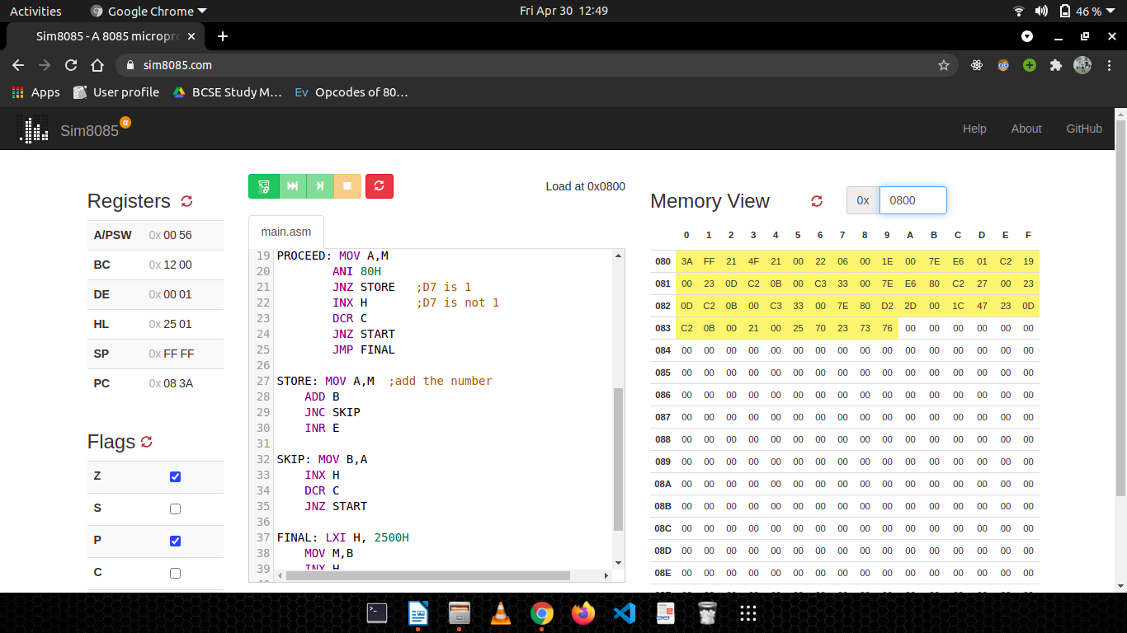

Sample input and output (M[2500]=05H, M[2501]=81H, M[2502]=11H, M[2503]=42H, M[2504]=26H, M[2501]=96H):

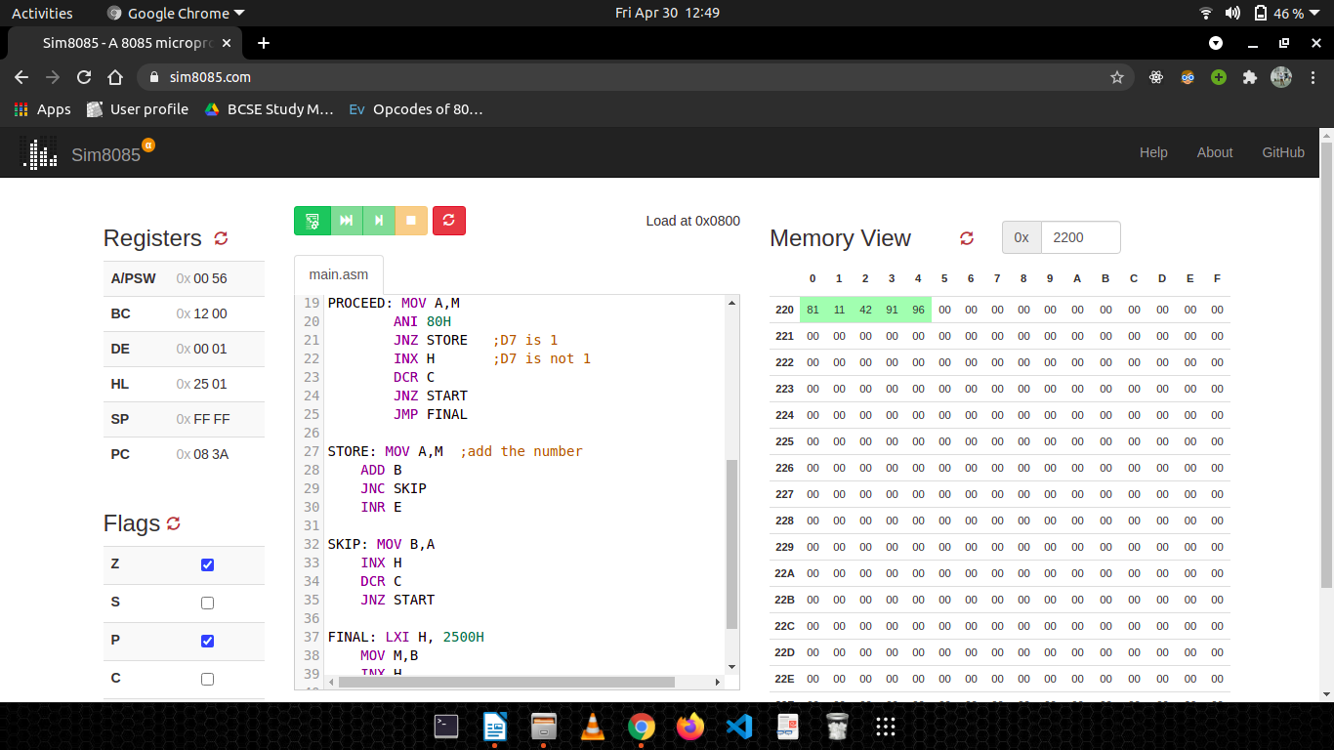

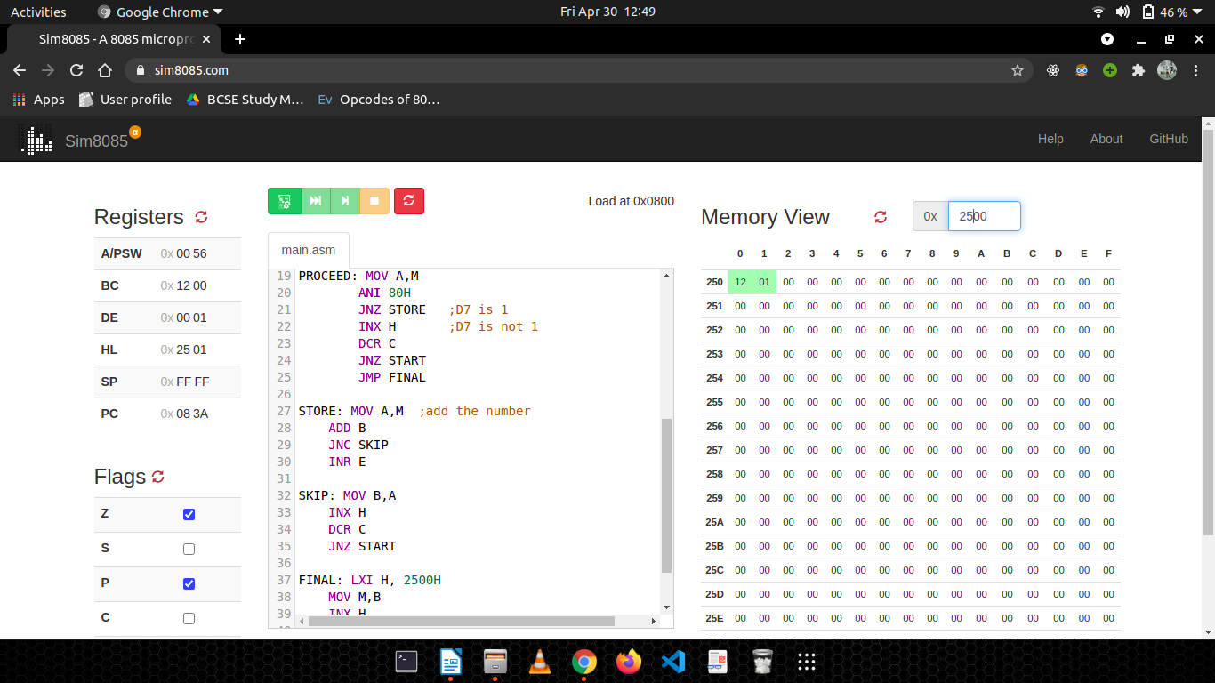

3. Write an 8085 program to generate N th fibonacci number using function and store it in 2050 H . The value of N (8-bits) is stored in memory 2060 H .

Line# | Address in Hex | Label | Instruction | Opcode in Hex | Remarks
1 | 0800 |  | LDA 2060H | 3A | A = M[2060H]
2 | 0801 |  | LDA 2060H | 60 | A = M[2060H]
3 | 0802 |  | LDA 2060H | 20 | A = M[2060H]
4 | 0803 |  | MOV C,A | 4F | C = A
5 | 0804 |  | XRA A | AF | Clear Accumulator
6 | 0805 |  | MOV B,A | 47 | B = A
7 | 0806 |  | MOV E,A | 5F | E = A
8 | 0807 |  | DCR C | 0D | C = C - 1
9 | 0808 |  | JZ EXIT | CA | Jump to EXIT if zero occurs
9 | 0809 |  | JZ EXIT | 19 | Jump to EXIT if zero occurs
9 | 080A |  | JZ EXIT | 08 | Jump to EXIT if zero occurs
10 | 080B | LOOP | ADD B | 80 | A = A + B
11 | 080C |  | MOV B,E | 43 | B = E
12 | 080D |  | MOV E,A | 5F | E = A
13 | 080E |  | DCR C | 0D | C = C - 1
14 | 080F |  | JNZ LOOP | C2 | Jump to LOOP if zero does not occur
14 | 0810 |  | JNZ LOOP | 11 | Jump to LOOP if zero does not occur
14 | 0811 |  | JNZ LOOP | 08 | Jump to LOOP if zero does not occur
15 | 0812 |  | MOV A,E | 7B | A = E
16 | 0813 | EXIT | STA 2050H | 32 | M[2050H] = A
 |  |  |  | 50 | M[2050H] = A
 |  |  |  | 20 | M[2050H] = A
17 | 0814 |  | HLT | 76 | Halt

Simulator with loaded machine code:
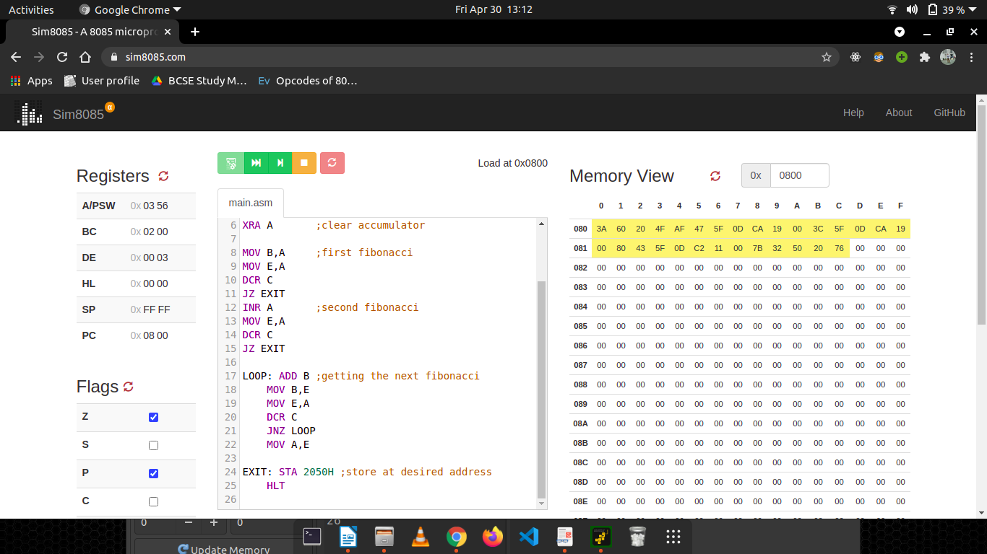

Sample input and output (M[2060H] = 05H, M[2050H] = 03H):

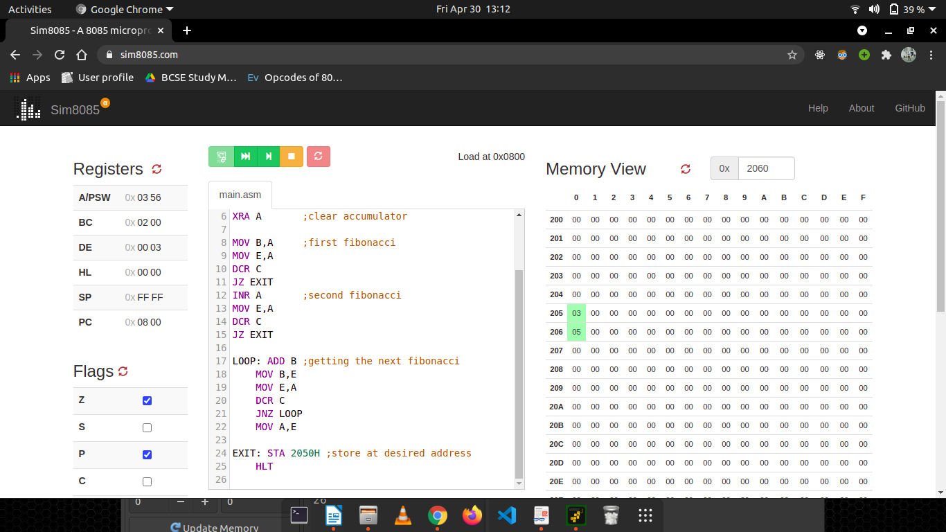

4. Write a program to transfer a block of bytes of size N from location1 to location2 (location2 > location1) when the size of overlap between the two locations is defined by M. The values of N and M are stored in 201E H and 201F H , respectively.

Line# | Address in Hex | Label | Instruction | Opcode in Hex | Remarks
1 | 0800 |  | LDA 2200H | 3A | A = M[2200H]
2 | 0801 |  | LDA 2200H | 00 | A = M[2200H]
3 | 0802 |  | LDA 2200H | 22 | A = M[2200H]
4 | 0803 |  | MOV E,A | 5F | E = A
5 | 0804 |  | MVI D,00H | 16 | D = 00H
6 | 0805 |  | MVI D,00H | 00 | D = 00H
7 | 0806 |  | LXI H, 2210H | 21 | H = 2210H
7 | 0807 |  | LXI H, 2210H | 10 | H = 2210H
7 | 0808 |  | LXI H, 2210H | 22 | H = 2210H
8 | 0809 |  | DAD D | 19 | HL = HL + DE
9 | 080A |  | DCX H | 2B | H ->H - 1
10 | 080B |  | MOV B,H | 44 | B = H
11 | 080C |  | MOV C,L | 4D | C = L
12 | 080D |  | LDA 2201H | 3A | A = M[2201H]
12 | 080E |  | LDA 2201H | 01 | A = M[2201H]
12 | 080F |  | LDA 2201H | 22 | A = M[2201H]
13 | 0810 |  | MOV D,E | 53 | D = E
14 | 0811 |  | MOV E,A | 5F | E = A
15 | 0812 |  | MOV A,D | 7A | A = D
16 | 0813 |  | SUB E | 93 | A = A - E
17 | 0814 |  | MOV E,A | 5F | E = A
18 | 0815 |  | MOV A,D | 7A | A = D
19 | 0816 |  | MVI D, 00H | 16 | D = 00H
19 | 0817 |  | MVI D, 00H | 00 | D = 00H
20 | 0818 |  | DAD D | 19 | HL = HL + DE
21 | 0819 |  | MOV D,A | 57 | D = A
22 | 081A | REPEAT | LDAX B | 0A | A = M[B]
23 | 081B |  | MOV M,A | 77 | M = A
24 | 081C |  | DCX B | 0B | B -> B - 1
25 | 081D |  | DCX H | 2B | H -> H - 1
26 | 081E |  | DCR D | 15 | D = D - 1
27 | 081F |  | JNZ REPEAT | C2 | Jump to REPEAT if zero does not occur
27 | 0820 |  | JNZ REPEAT | 1A | Jump to REPEAT if zero does not occur
27 | 0821 |  | JNZ REPEAT | 08 | Jump to REPEAT if zero does not occur
28 | 0822 |  | HLT | 76 | Halt

Simulator with loaded machine code:

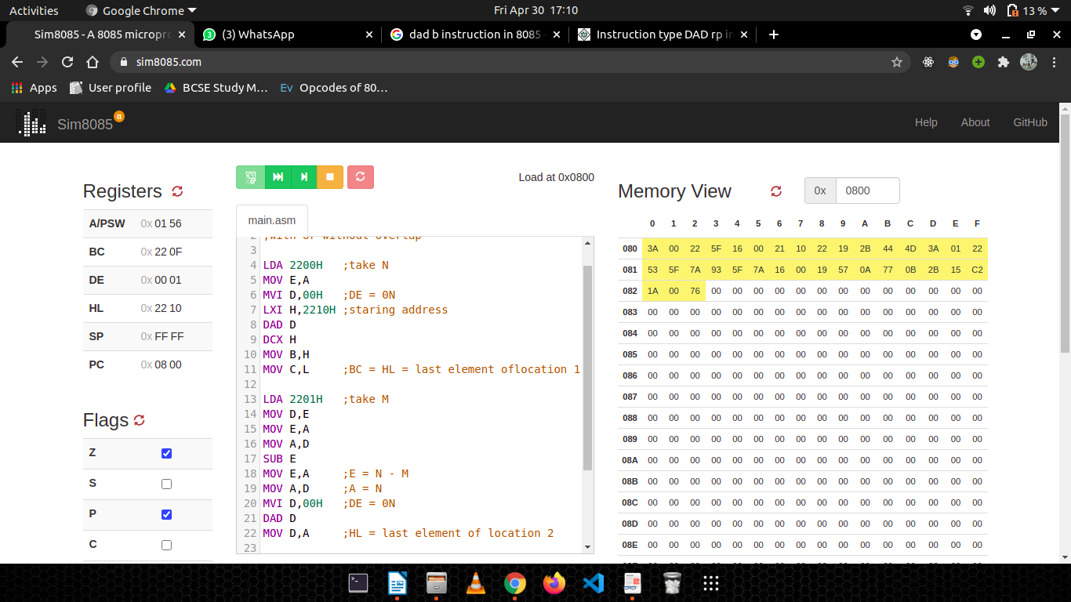

Sample input and output ( M[2200] = 05H, M[2201] = 01H, M[2210H] = 01H, M[2211H] = 02H, M[2212H] = 03H, M[2213H] = 04H, M[2214H] = 05H):

